A Project Report On

**HOSPITAL MANAGEMENT SYSTEM**

Submitted in the partial fulfilment for the degree of

**Bachelor of Technology in**

**Electronics and Communication Engineering**

**From**



Submitted By

|  |  |
| --- | --- |
| Anushka Dey | (24400317047) |
| Sourav Paul | (24400317010) |
| Sourav Roy | (24400317009) |
| Surya Das | (24400317006) |

Under support and guidance of

**Mrs. Roshni Chakrabarti**

Assistant Professor, Department of ECE

Submitted To

**Techno Engineering College Banipur**

For Academic year

**2020-2021**

**RECOMMENDATION**

*It is hereby recommended that the project report entitled “Hospital Management System”, prepared and submitted by Anushka Dey, Sourav Paul, Sourav Roy, Surya Das as Final Year Project from the Department of Electronics and Communication Engineering of*

*Techno Engineering College Banipur under Maulana Abul Kalam Azad University of Technology , West Bengal accepted as final year project report.*

______________________

***Mrs. Roshni Chakrabarti***

*Asst. Prof. of E.C.E Dept.*

*&*

*Project Guide*



**TECHNO ENGINEERING COLLEGE BANIPUR**

**CERTIFICATE OF APPROVAL**

This is to certify that the content of this project entitled, “Hospital Management System” by *Anushka Dey, Sourav Paul, Sourav Roy and Surya Das* successfully submitted their work to Techno Engineering College, Banipur under guidance of *Mrs. Roshni Chakrabarti*, Assistant Professor of Department ECE, for consider in the partial fulfilment of the requirement of Maulana Abul Kalam Azad University of Technology, West Bengal for the award of Bachelor of Technology in Electronics and Communication Engineering.

The report in its present form satisfies all the requirements, as specified by Techno Engineering College Banipur and also as per the regulations of the Maulana Abul Kalam Azad University of Technology (MAKAUT). In fact, it has attained the standard necessary for submission to the best of my knowledge, the results embodied in this report are original in nature and worthy of incorporation in the present version of the report of Bachelor of Technology in Electronics and Communication Engineering.

Certified By-

_______________________ ______________________

***Dr. Maloy Kumar Chandra Mr. Sanjib Kumar Dhara***

*Principal of T.I.C of E.C.E Dept.*

*Techno Engineering College, Banipur*

______________________

***Mrs. Roshni Chakrabarti***

*Asst. Prof. of E.C.E Dept.*

*&*

*Project Guide*

* **Acknowledgement:**

We would sincerely like to express thanks and gratitude our mentor “***Mrs. Roshni Chakrabarti***”, and our T.I.C “***Mr. Sanjib Kumar Dhara***”, for providing us the golden opportunity to do this wonderful project on “**Hospital Management System”**. Which also helped us to do a lot of research and further enhance our knowledge.

We would also like to extend our gratitude to our principal “***Dr. Maloy Kumar Chandra***”, who allowed us to do this wonderful project.

We also hugely thank all the group members for their contribution and cooperation for making this project a success. Without them this would not be possible in the limited time.

We whole heartily thank to all of the people who contributed to make this project a successful one.

_______________________

Anushka Dey (24400317047)

_______________________

Sourav Paul (24400317010)

_______________________

Sourav Roy (24400317009)

_______________________

Surya Das (24400317006)

* **Abstract:**

The purpose of the project entitled as **‘Hospital Management System’** is to computerize the Front Office Management of Hospital to develop software which is user friendly simple, fast, and cost – effective.

The project **‘Hospital Management System’** is based on the database, object oriented and networking techniques. As there are many areas where we keep the records in database for which we are using MY SQL software which is one of the best and the easiest software to keep our information. This project uses JAVA as the base software which is an Object-Oriented Programming language and has connectivity with MySQL.

The main aim of the entire activity is to automate the process of day-to-day activities of hospital like patient details, admission of a new patient, update the patient record, full history of the patient, and finally compute the bill etc.

* **Contents:**

**** **Acknowledgement** 1

**** **Abstract** 2

**** **List of Figures:** 4

**** **List of Flowcharts and E-R Diagrams:** 5

**** **Introduction** 7

**** **Process and Technologies** 9

**➢** **Technologies** 9

**1)** **Java 8** 9

**2)** **Java Swing** 9

**3)** **MySQL** 9

**4)** **IDE** 11

**5)** **JDBC(Java Data Base Connectivity)** 11

**6)** **Window Builder** 11

**7)** **Launch4j** 11

**➢** **Process** 11

**a.** **Front-End** 11

**b.** **Back-End** 14

**** **Simulation and Output** 26

**** **Conclusions** 36

**** **Importance:** 38

**** **References** 40

# **List of Figures:**

|  |  |  |
| --- | --- | --- |
| No. | Name of Figures | Page No. |
| 1. | Eclispe Marketpalce………………………………... | 12 |
| 2. | Window Builder……………………………………. | 12 |
| 3. | Creating New Project………………………………. | 13 |
| 4. | JFrame Project……………………………………... | 13 |
| 5. | Source and Design Tab…………………………….. | 14 |
| 6. | List of Components………………………………… | 14 |
| 7. | Patient Table……………………………………….. | 23 |
| 8. | Diagnosis Fees Table………………………………. | 24 |
| 9. | User Credential Table……………………………… | 24 |
| 10. | Initial Login Screen………………………………... | 26 |
| 11. | Login Screen……………………………………….. | 26 |
| 12. | Error Message……………………………………… | 27 |
| 13. | Home Screen……………………………………….. | 27 |
| 14. | Add New Record Screen…………………………… | 28 |
| 15. | Successful Upload Message……………………….. | 28 |
| 16. | Initial Update Record Screen………………………. | 29 |
| 17. | Invalid ID Update Record Screen………………….. | 29 |
| 18. | Valid ID Update Record Screen…………………… | 30 |
| 19. | Successful Update Message……………………….. | 30 |
| 20. | Initial View Record Screen………………………… | 31 |
| 21. | Invalid Details Record Screen……………………... | 31 |
| 22. | Valid Records……………………………………… | 32 |
| 23. | Initial Get Bill Screen……………………………… | 32 |
| 24. | Invalid ID Get Bill Screen…………………………. | 33 |
| 25. | Valid ID Get Bill Screen…………………………… | 33 |
| 26. | Log-Out Confirmation…………………………….. | 34 |

# **List of Flowcharts and E-R Diagrams:**

|  |  |  |
| --- | --- | --- |
| No. | Name of Diagrams | Page No. |
| 1. | Over All Project ………………………………. | 15 |
| 2. | Connection Provider class ……………………. | 16 |
| 3. | Login Screen class ……………………………. | 17 |
| 4. | Home Screen class ……………………………. | 18 |
| 5. | Add New Record Screen class ………………... | 19 |
| 6. | Update Record Screen class …………………... | 20 |
| 7. | View Record Screen class…………………….. | 21 |
| 8. | Get Bill Screen class…………………………... | 22 |
| 9. | E-R Diagram…………………………………... | 23 |

INTRODUCTION

* **Introduction:**

Human Body is a very complex and sophisticated structure and comprises of millions of functions. All these complicated functions have been understood by man him, part-by-part their research and experiments. As science and technology progressed, medicine became an integral part of the research. Gradually, medical science became an entirely new branch of science. As of today, the Health Sector comprises of medical institutions i.e., Hospitals, research and development institutions and medical colleges. Thus, the Health sector aims at providing the best medical facilities to the common man.

The Hospital Management System can be entered using a username and password. It is accessible either by an administrator or receptionist. Only they can add data into the database. The data can be retrieved easily. The interface is very user-friendly. The data are well protected for personal use and makes the data processing very fast.

Hospital Management System is powerful, flexible, and easy to use and is designed and developed to deliver real conceivable benefits to hospitals.

Hospital Management System is designed for multispeciality hospitals, to cover a wide range of hospital administration and management processes. It is an integrated end-to-end Hospital Management System that provides relevant information across the hospital to support effective decision making for patient care, hospital administration and critical financial accounting, in a seamless flow.

Hospital Management System is a software product suite designed to improve the quality and management of hospital management in the areas of clinical process analysis and activity-based costing. Hospital Management System enables you to develop your organization and improve its

effectiveness and quality of work. Managing the key processes efficiently is critical to the success of the hospital helps you manage your processes.

PROCESS

& TECHNOLOGIES

* **Process and Technologies:**

In this project, the most vital step is to make the user interface friendly as well as to make the project secure so that the chances of data leak or corruption is low. There are many technologies to build this project. The list of technologies are given below for this project:

* **Technologies****:**

1. Java 8 (Base technology)
2. Java Swing
3. Java Data Base Connectivity
4. IDE (Eclipse)
5. MySQL
6. Window Builder (External Eclipse Module)
7. Launch4j (Third Party Software)
8. **Java 8:** Java is a universally well accepted platform independent programming language which is used in many fields in almost every industry. Java was used in making Symbian OS back in 90’s but nowadays Java is mainly used to make web application or android applications. Java has a lot of libraries and lot of modules which make it suitable for industrial projects and make programmer to code efficiently. Most accepted java version in java version 8.
9. **Java Swing:** In java to build a “window-based” application there are mainly two libraries present one is “AWT (Abstract Window Toolkit)” and another is “Java Swing”. But in this project java swing has been used because there are some advantages to use java swing over AWT.
10. AWT is platform Dependent where Java Swing is platform independent.
11. AWT components are heavy-weight but Java Swing components are light-weight.
12. AWT doesn’t support look and feel plugin which is mainly used for button and window designs and themes but Java Swing supports it.
13. AWT has very less components but Java Swing has a lot of components such as tables, lists, scrollpane etc.
14. **MySQL****:** One of the mandatory technologies for this project is DBMS to store the data and to operate on the data. To store data file also could be used but file is extremely insecure as well as consumes more memory and time whereas DBMS is well organized system to store data with atomicity and no duplication.

DBMS software primarily functions as an interface between the end user and the database, simultaneously managing the data, the database engine, and the database schema in order to facilitate the organization and manipulation of data. A database schema design technique that functions to increase clarity in organizing data is referred to as normalization. Normalization in DBMS modifies an existing schema to minimize redundancy and dependency of data by splitting a large table into smaller tables and defining the relationship between them. DBMS Output is a built-in package SQL in DBMS that enables the user to display debugging information and output, and send messages from subprograms, packages, PL/SQL blocks, and triggers. Oracle originally developed the DBMS File Transfer package, which provides procedures to copy a binary file within a database or to transfer a binary file between databases.

There is a term known as RDBMS (Relational Data Base Management System) which similar to DBMS but with little difference:

1. Structure: Where data is structured in hierarchical form in a DBMS, data is structured in tabular form in a RDBMS.
2. **User capacity**: A RDBMS is capable of operating with multiple users. DBMS can only manage one user at a time
3. Programs managed: DBMS maintains databases within the computer network and system hard disks. A RDBMS manages the relationships between its incorporated tables of data.
4. Data capacity: A DBMS is capable of managing small amounts of data and a RDBMS can manage an unlimited amount of data.Distributed databases: A DBMS does not provide support for distributed databases while a RDBMS does.
5. ACID implementation: A RDBMS bases the structure of its data on the ACID (Atomicity, Consistency, Isolation, and Durability) model.

There is many software to create and operate Data base such as SQL, MySQL, But MySQL is widely used and free and light weight so in this project MySQL is used.

1. **IDE****:** An integrated development environment (**IDE**) is software for building applications that combines common developer tools into a single graphical user interface (GUI). There are many Java IDE such as NetBeans, Eclipse, Visual Studio. Any of the IDE will give same output it is totally user choice. In this project Eclipse has been used.
2. **JDBC(Java Data Base Connectivity)****:** Java Database Connectivity (JDBC) is an application programming interface (API) for the programming language Java, which defines how a client may access a database. It is a Java-based data access technology used for Java database connectivity. It is part of the Java Standard Edition platform, from Oracle Corporation. To connect the database with java program some libraries or driver needed to be installed or included in the project. In this project “mysql-connector-java-8.0.20” has been used.
3. **Window Builder****:** Window Builder is powerful plugin to eclipse for making window-based application layout with simple user face. This external plug in needs to be downloaded and installed after that with help of a drag and draw interface easily a window and its component can be added and customised.
4. **Launch4j:** Launch4j is a third-party software which was used to convert the JAR project file to EXE so that the application can be run in any device.

* **Process****:**

In window-based application there are mainly two steps i) Front-end and ii) Back-end. Other than front-end and back-end there is one more step is to implementation of proper database.

1. **Front-End:** Front-end of any project means the end of user side meaning the user interface which is help the user to understand the application and its features. It mainly consists of windows, some buttons of different types or same types, text fields, some output dialogues. In this project Eclipse Window Builder was used to make the user interface easier with drag and draw technique. Steps of making a responsive window in window builder are given below:
2. To use Window Builder, plug in of eclipse it is needed to be installed in the system. To install it there is a market place in Eclipse. To find the market place **open Eclipse->Help->Eclipse Marketplace (fig-I.a)->search window builder and install(fig-I.b).**

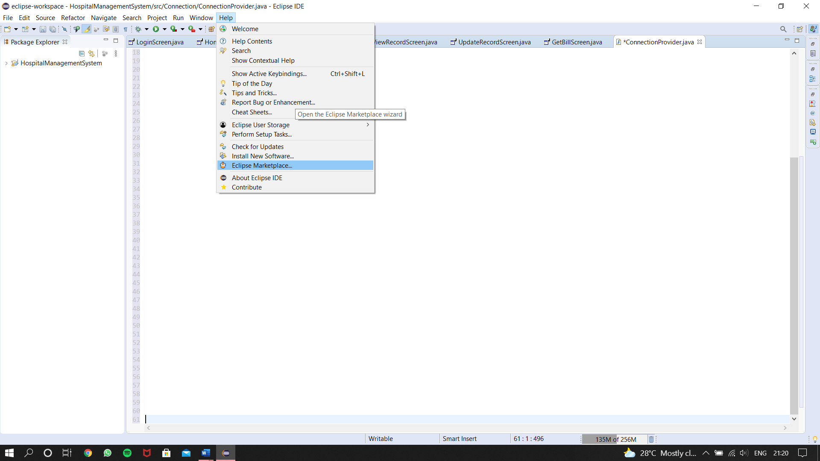

Fig-**I.a**: Eclispe Marketpalce

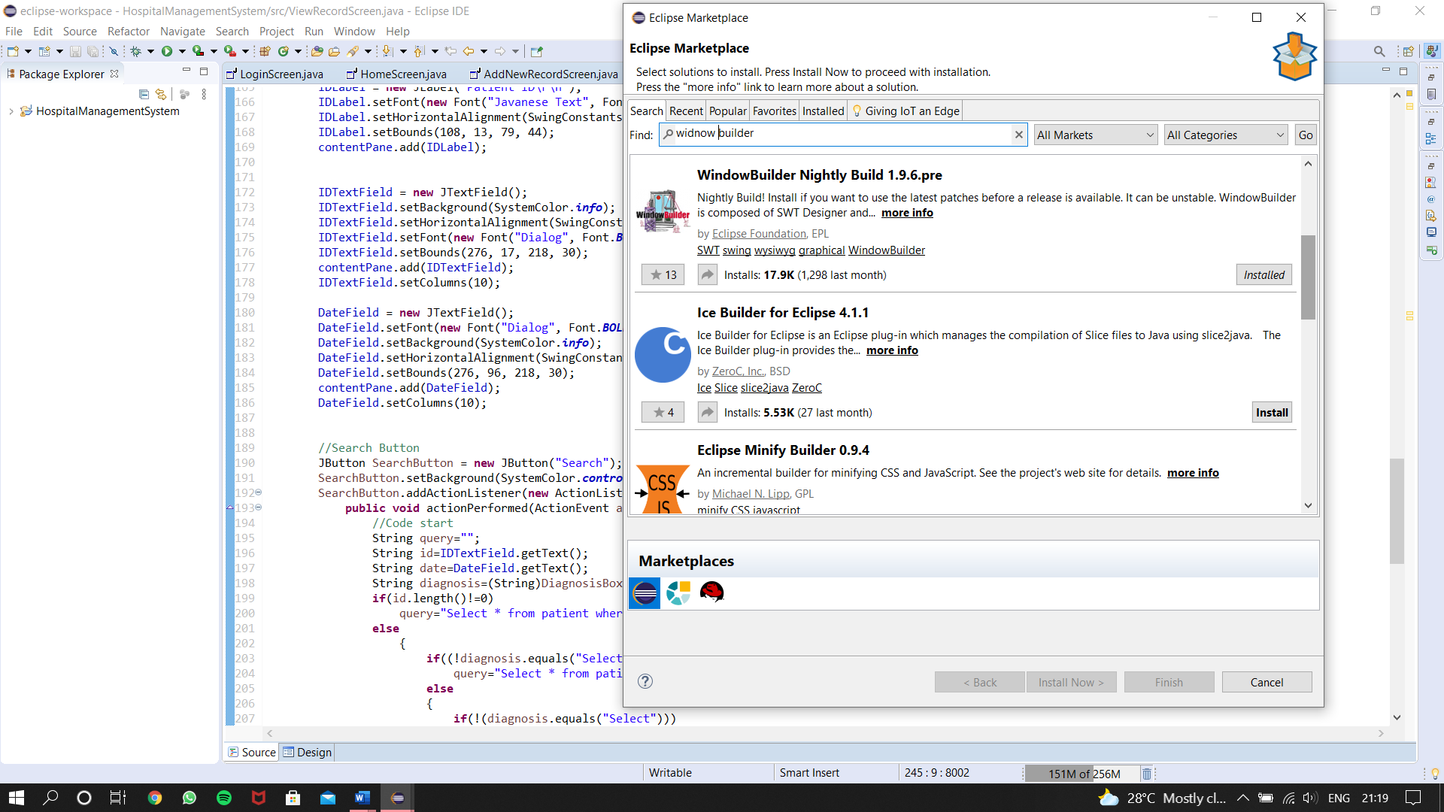

Fig-**I.b**: Window Builder

1. After installing window builder a project need to be created in eclipse and then in that project a JFrame class needs to be created. For every window there will be individual JFrame classes. To do so **Right click on the package of the project->New->Other(fig-II.a)->window Builder->Swing Designer->JFrame->Next(fig-II.b)**.

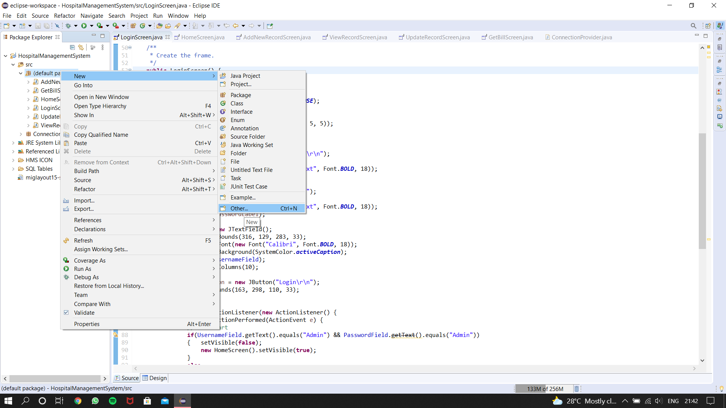

Fig-**II.a**: Creating New Project

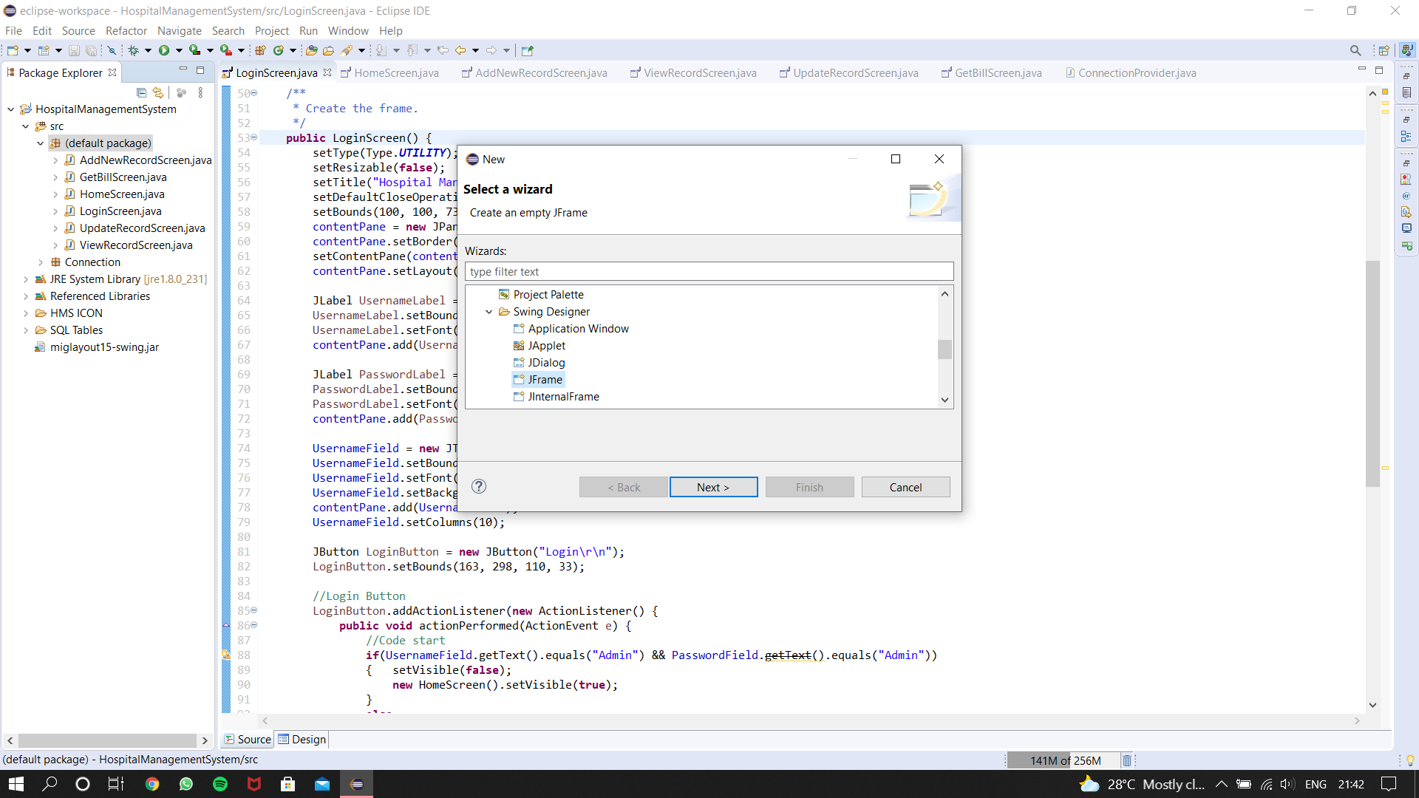

Fig-**II.b**: JFrame Project

1. After that give a name to that JFrame file and click finish to open the source file. The name of the JFrame file will be the class file for the window (JFrame).
2. In the JFrame file there are two tabs “Source” and “Design” (fig-IV.a). In design tab there are list of components which can be used to design a window visually using drag and draw technique. In the source tab the code of respective design will be generated as well as to implement the back-end algorithm or to make any custom changes in the components the necessary code will be written in source tab.

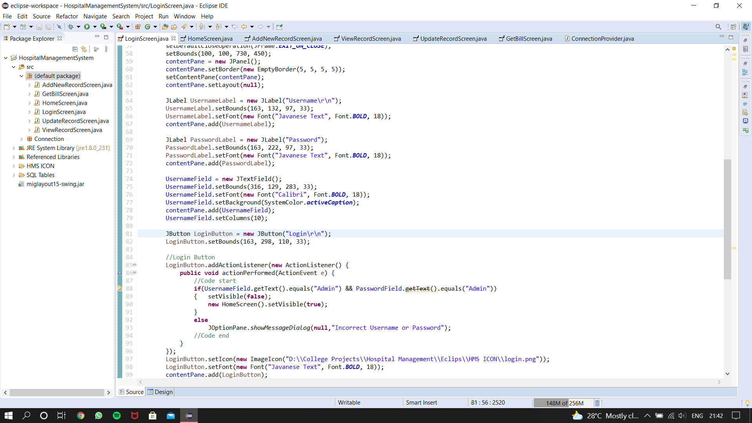

Fig-**IV.a**: Souce and Design Tab

1. In design tab there are the necessary components (fig-V.a) for a window and necessary properties info and setting for a particular component to customize it.

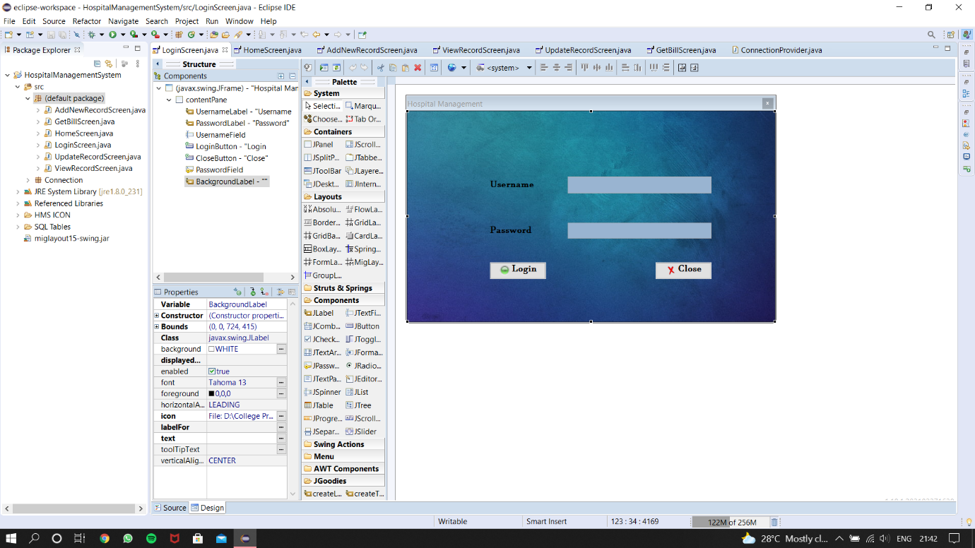

Fig-**V.a**: List of components

1. **Back-End:** In the front end the user end(Interface) is being designed properly but it will not be responsive if the algorithm is not implemented. The implementation of the algorithm is called Back-End.

To implement a proper algorithm and to understand it a proper flowchart is required. Flow chart for total algorithm as well as flowchart for each and every class. So that the algorithm can be implemented easily and can be understood by anyone.

* 1. **Flow Chart:**

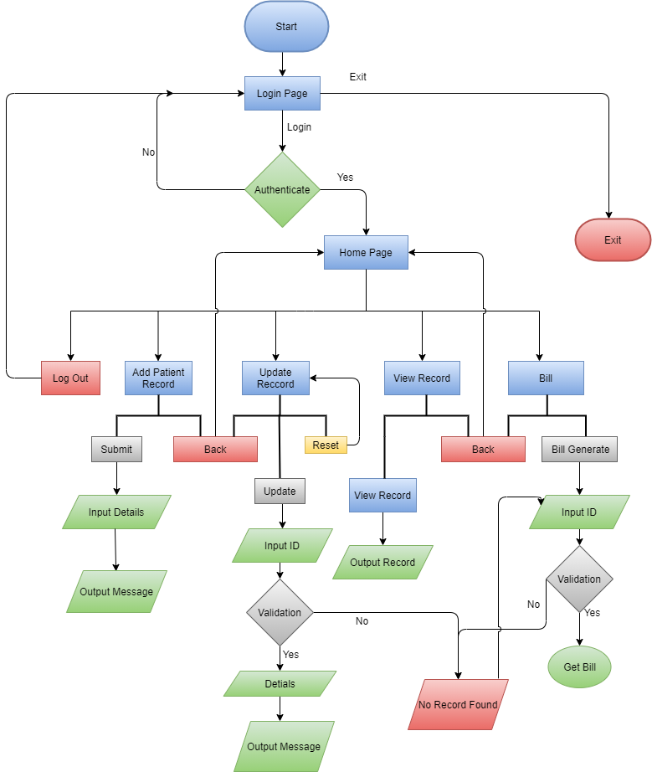

* 1. **Classes:**

As JAVA is a object oriented programming language that means there a class for every object. Without class there can not exist an object. In JFrame for each and every window there is a class that means if there is total 5 different windows then there will be at least 5 java classes. In this project there are total 7 classes:

1. **ConnectionProvider Class**: This class has only one method which is “getCon()” method. Which is used to make connection with a particular schema in from the database so that the program can have the access to read the data from a database. Flow chart of getCon() method:

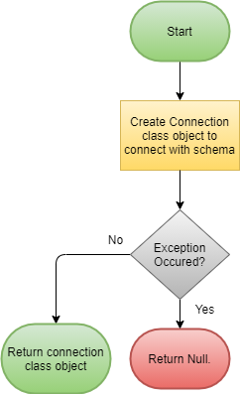

1. **LoginScreen class**:The very first window of the project is login screen. In the login screen the user will have to login with correct username and password to get access to the main app. This window consist of 2 buttons and 2 text fields. Flow chart is given below:

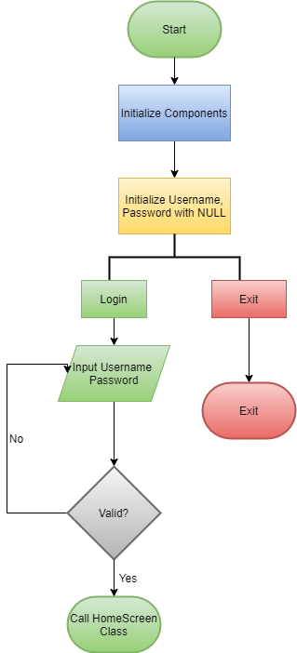

1. **HomeScreen class**:Home Screen is the main window after login from where the user can access all the features of the application such as adding new record, viewing all record, updating, bill generate or logout. This window has only 5 buttons as window component. Flow chart of this window given below:

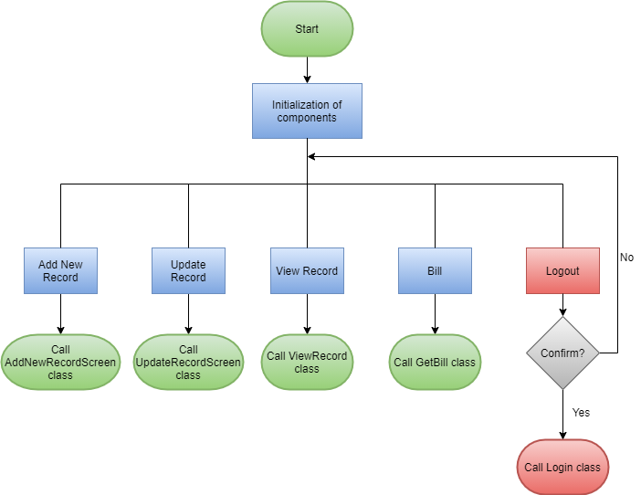

1. **AddNewRecordScreen class**: This window is to add new patient record in the data base. This window consists of some text fields and drop-down menus and 2 buttons. One for submit the new record another is to go back to home screen. This window has the access to database so that the records can be inserted to database. Flow chart of this class is given below:

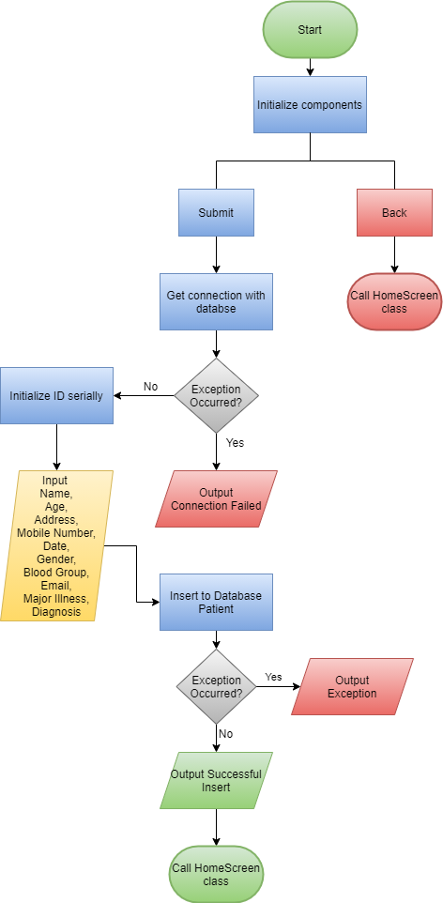

1. **UpdateRecordScreen Class:** Update record window and add new record window are almost similar. They have the same number of text fields for input only difference is the purpose of both windows. Update record window is to update any existing data or record. In add record window every text field was mandatory to fill but in update record screen any field can be left unfilled.

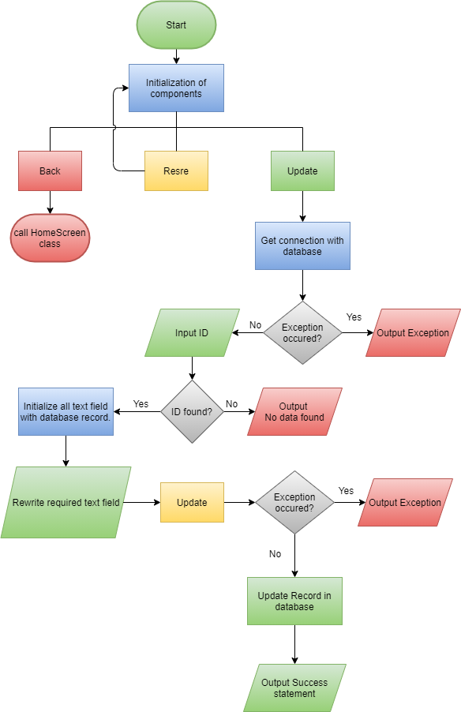

1. **ViewRecordScreen class:** To view the records of patient from the database this window will be used. This window has the features to customize search option for a particular type record. This window has some buttons and a Jtable so display records.

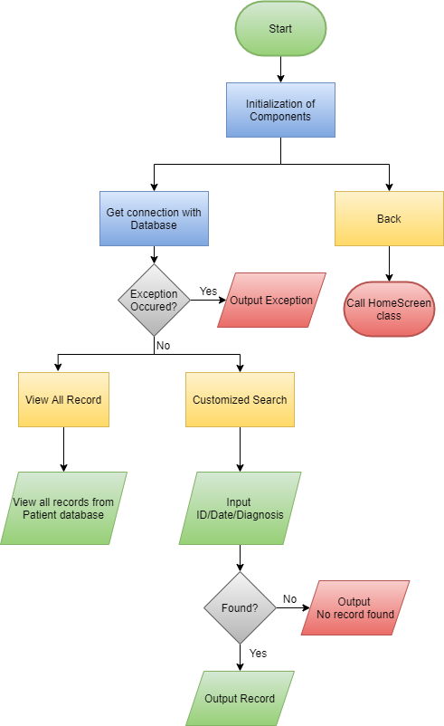

1. **GetBill class:** To generate bill of a patient there should be a feature. Similarly in this project there is a bill generate option. Which will extract the diagnosis data from the patient record table and then find the fees from the fees table according to diagnosis data.

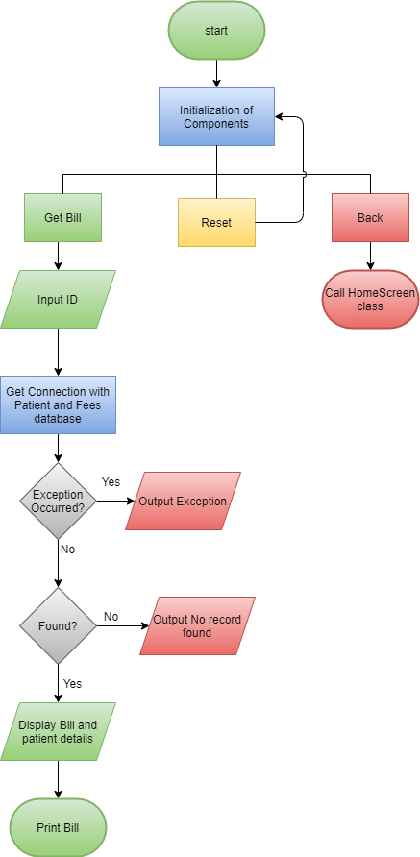

1. **Data Bases:** Apart from the application one of the most important component is database. Without database the application could not be data responsive. In this project there are 3 databases, i) Patient table ans ii) Fees table, iii) User Credentials Table.

* **E-R Diagram:**

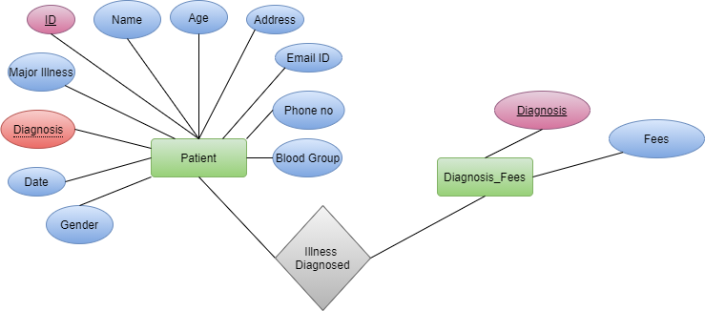

* + 1. **Patient Table:** This table is the main database which holds the records of every patient details. Same patient can have different ID based on their diagnosis and date of visiting.The data base has 12 attributes(ID, Name, Age, Address, Mobile number, Date, Major Illness, Email ID, Gender, Blood Group, Diagnosis) and ID is primary key. Over view of this data base(figure-c.1):

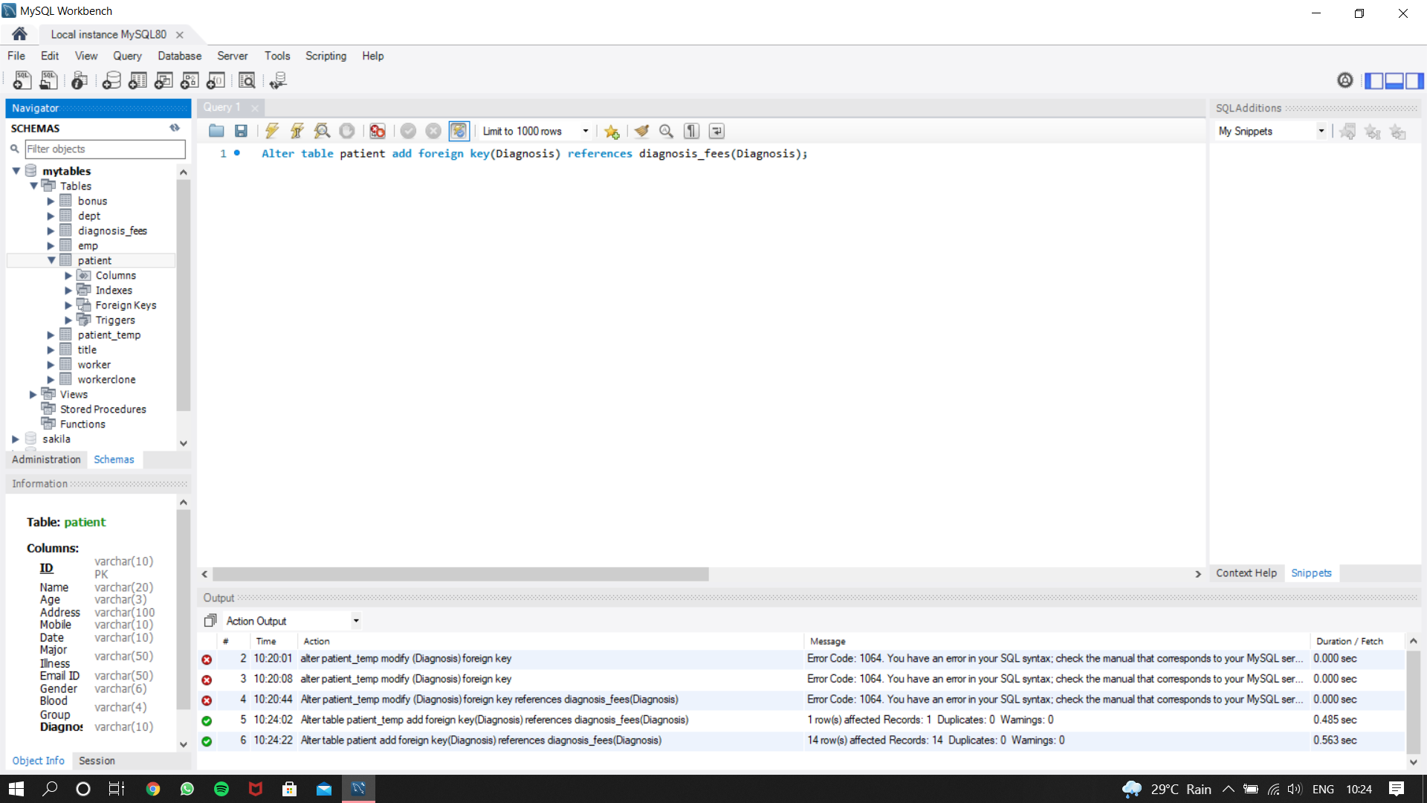

Fig**-C.1:**Patient Table

* + 1. **Diagnosis_fees Table:** This table has the data of every diagnosis department fees. This database has only 2 column one for department name which is Diagnosis which is also the primary key another for fees (figure-C.2).

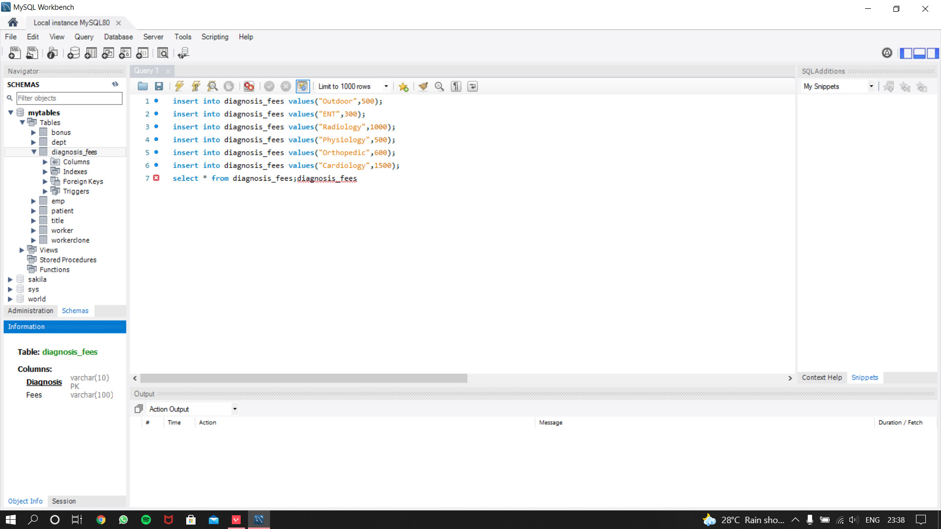

Fig**-C.2:**Diagnosis Fees Table

* + 1. **User_Credentials Table:** This table consist of the details of user credentials of the users who has access to the application (fig-C.3).

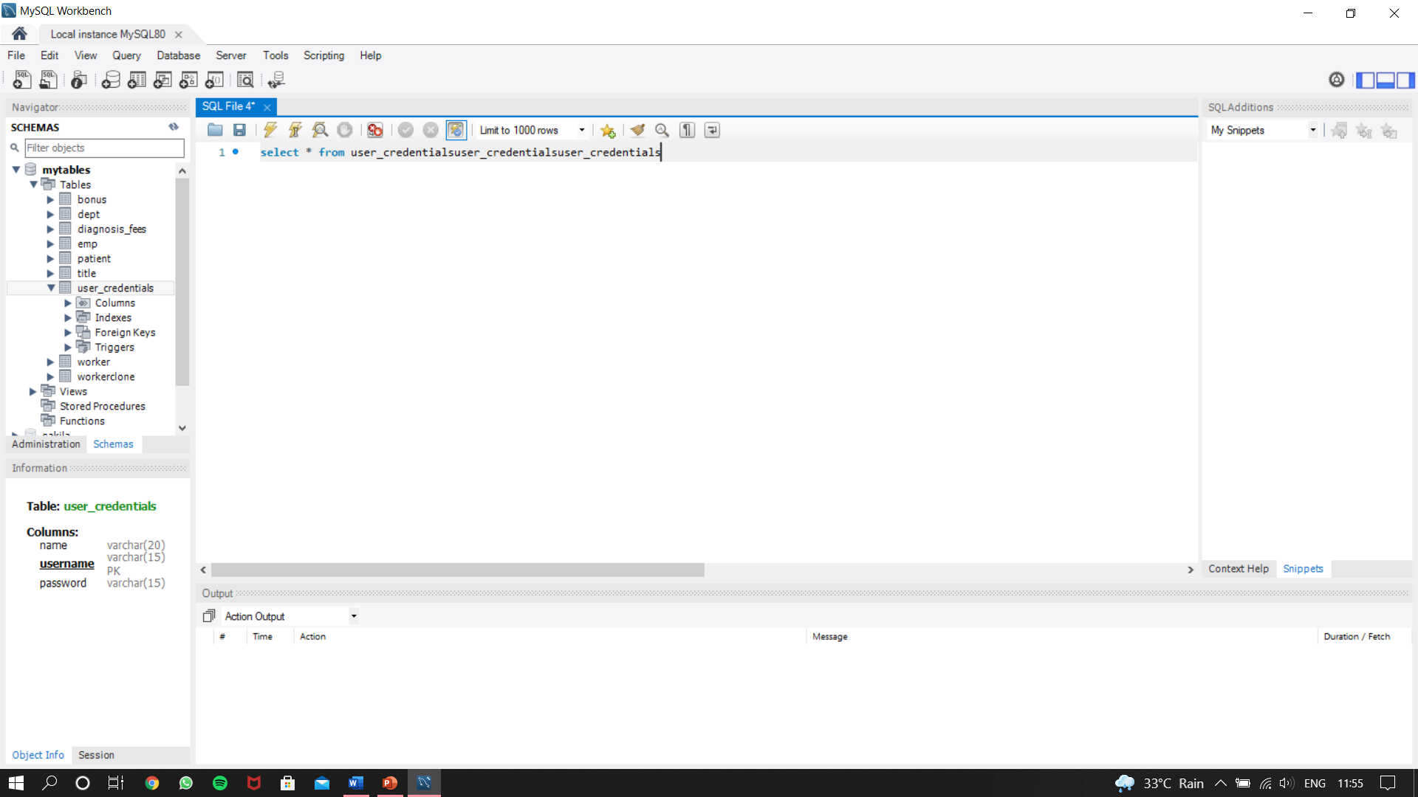

**Fig-C.3:**User Credentials Table

**SIMULATION**

**&**

**OUTPUT**

* **Simulation and Output:**

1. **Login Window:** Login window is the first window> User have to login to get the full access of the application.
   1. Login Window (fig-1.a,1.b)

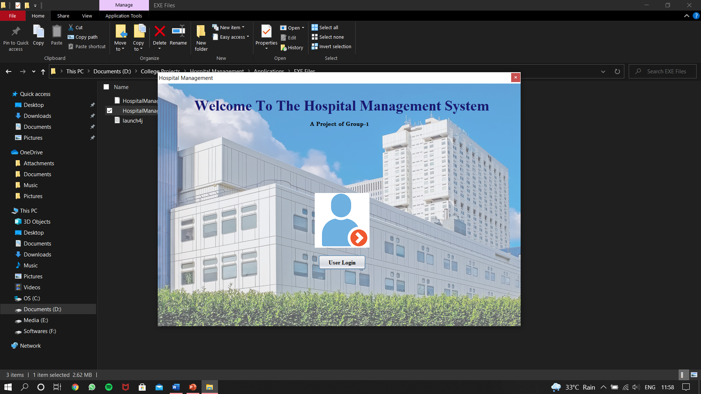

Fig-**1.a:** Initial Login Screen

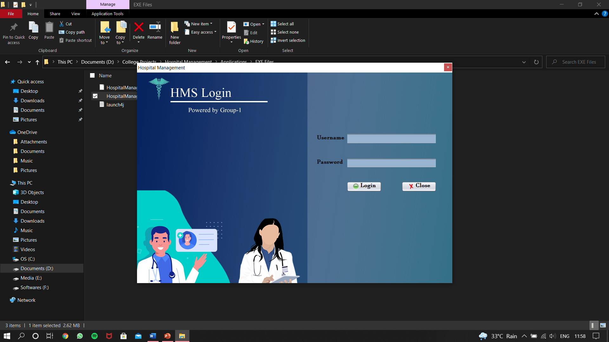

Fig-**1.b:** Login Screen

* 1. Wrong Username and Password Warning (fig-1.c)

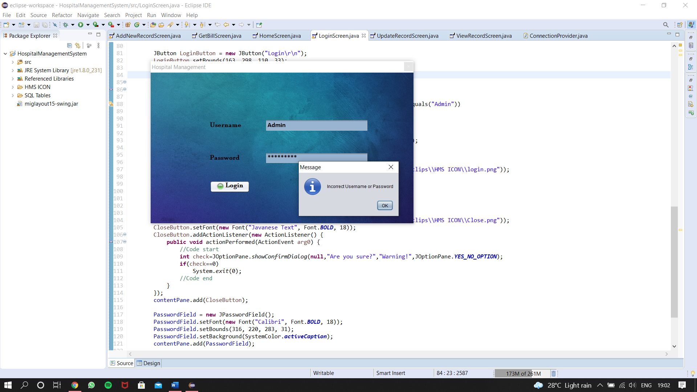

Fig-**1.c:** Error Message

1. **Home Window:** After successful login the next window is home window from where all features can be used.
   1. Home Screen (fig-2.a)

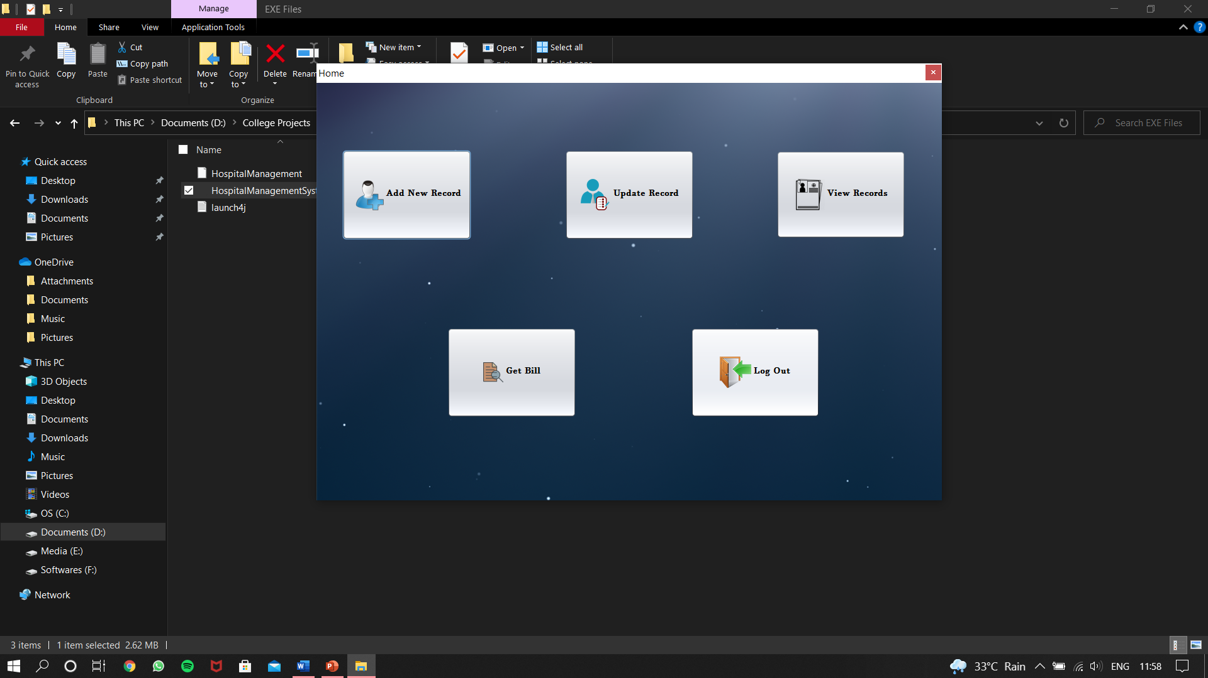

Fig-**2.a:** Home Screen

1. **Add New Record Window**: Add new record window is for adding new patient record.
   1. Initial Screen (fig-3.a)

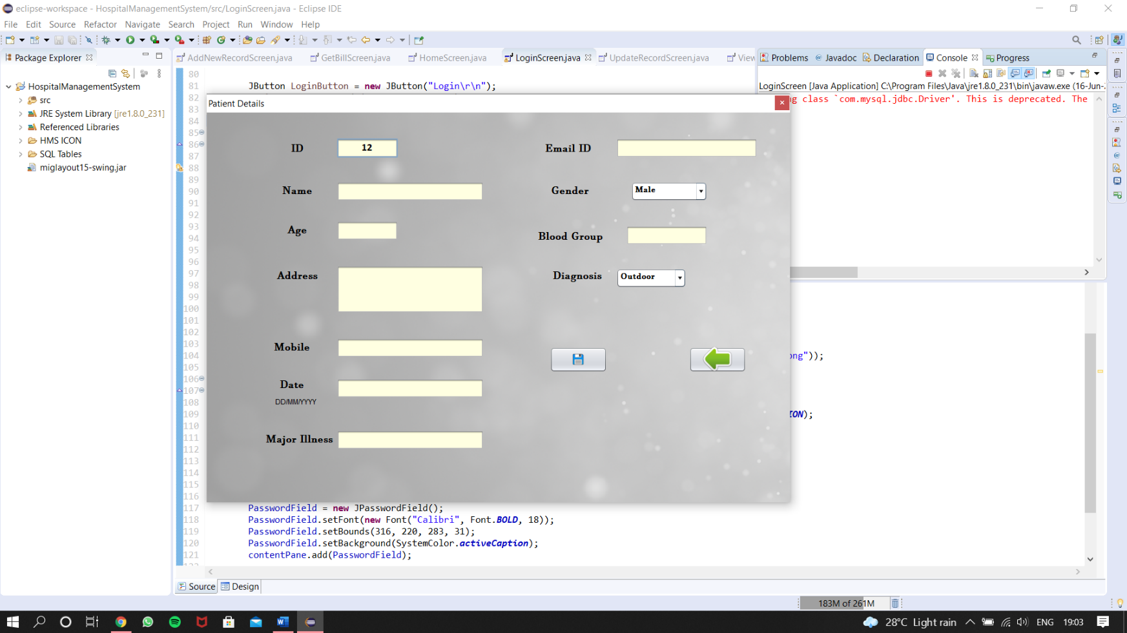

Fig-**3.a:** Add New Record Screen

* 1. Message after successful record upload (fig-3.b).

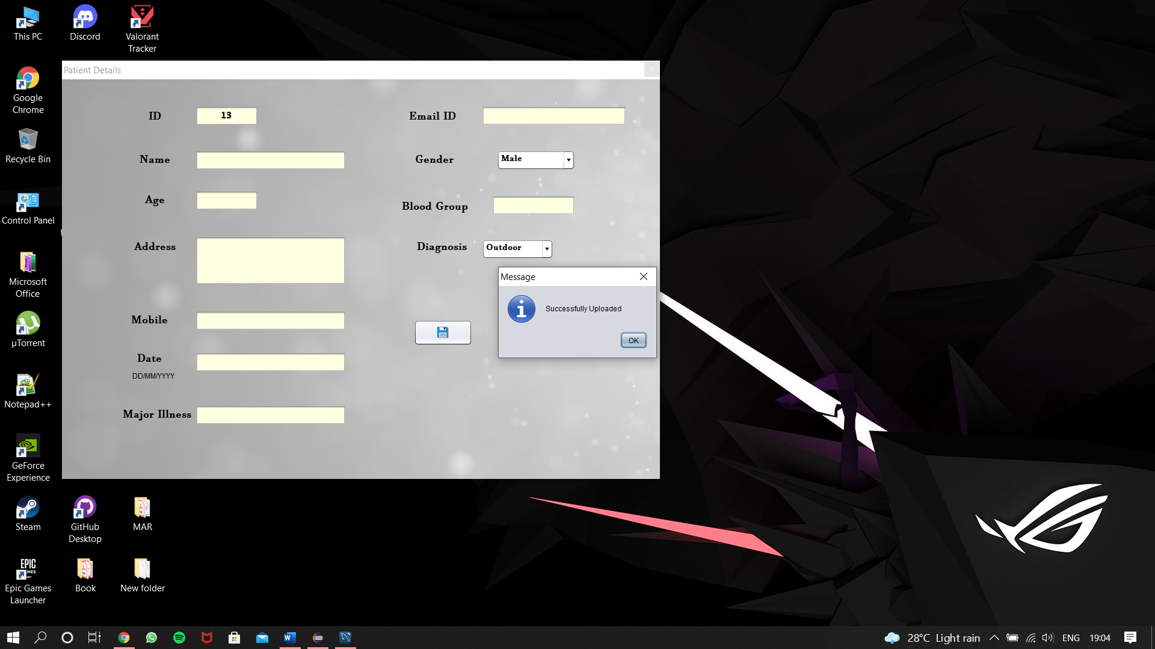

Fig-**3.b:** Successful Upload Message

1. **Update Record Window:** This window updates any existing record.
   1. Initial Window and window after reset (fig-4.a)

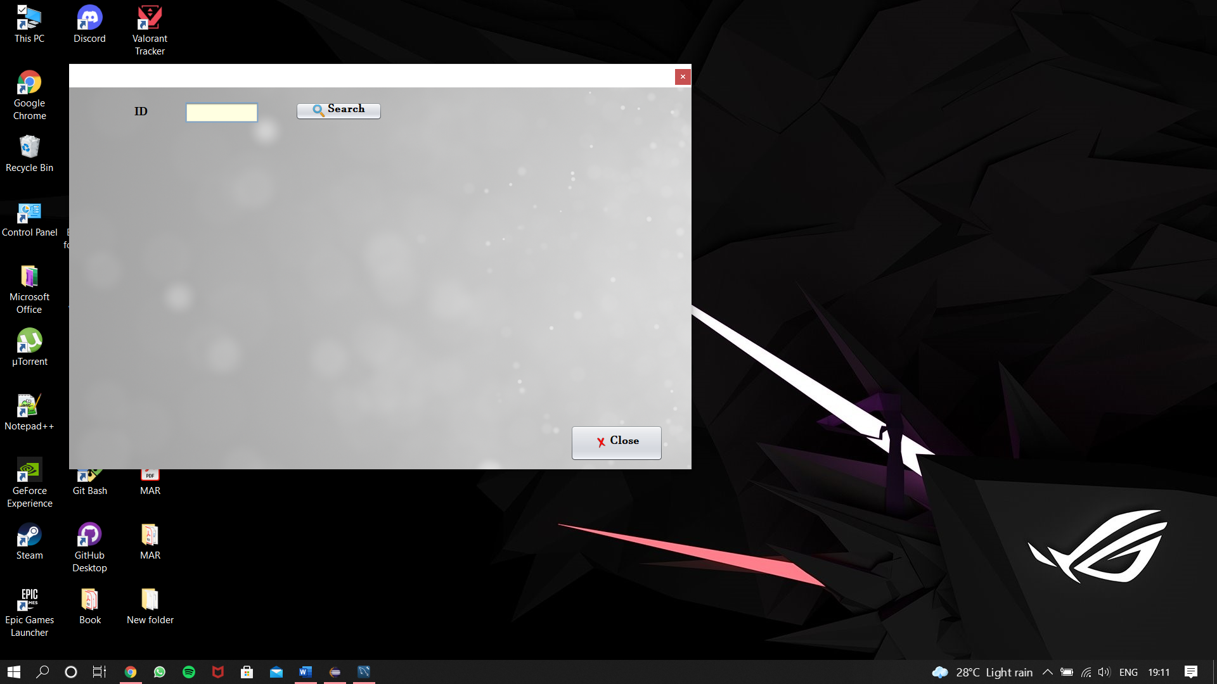

Fig-**4.a:** Initial Update Record Screen

* 1. If ID not found (fig-4.b)

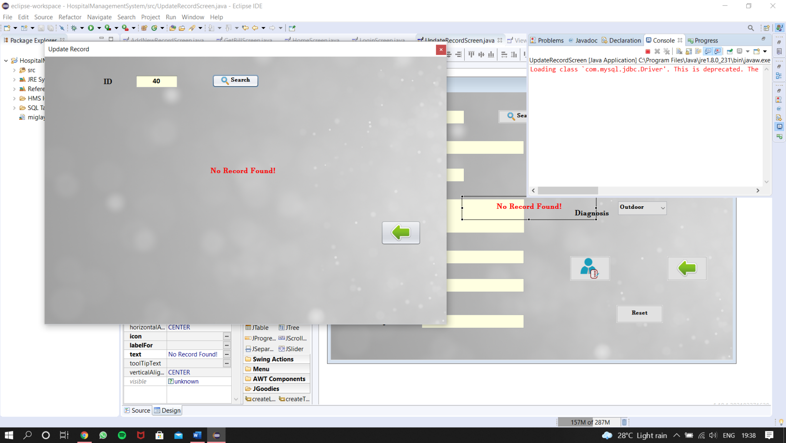

Fig-**4.b:** Invalid ID Update Record Screen

* 1. If ID found then the updated window (fig-4.c)

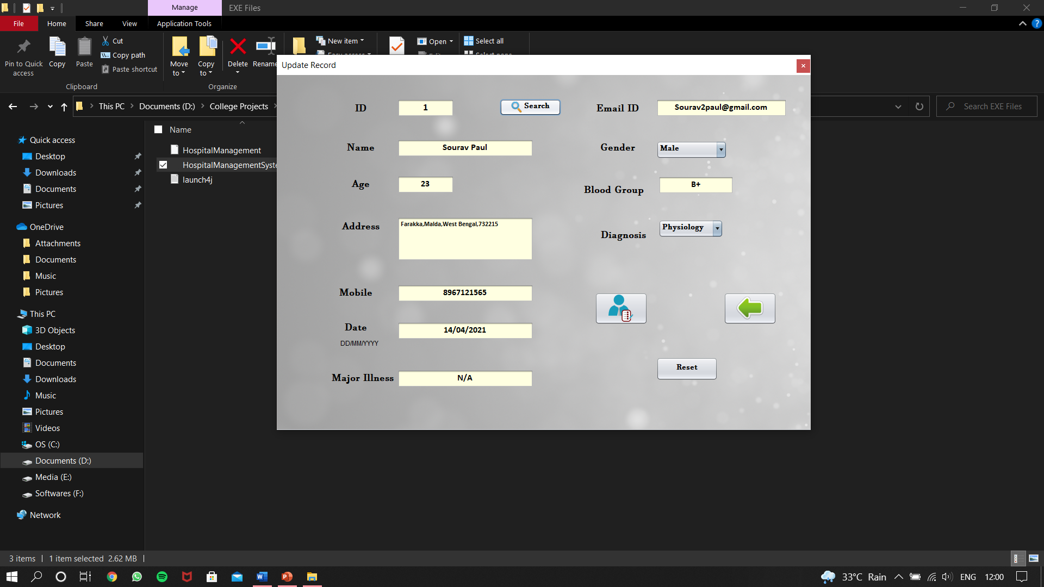

Fig-**4.c:** Valid ID Update Record Screen

* 1. Message after successful update (fig-4.d)

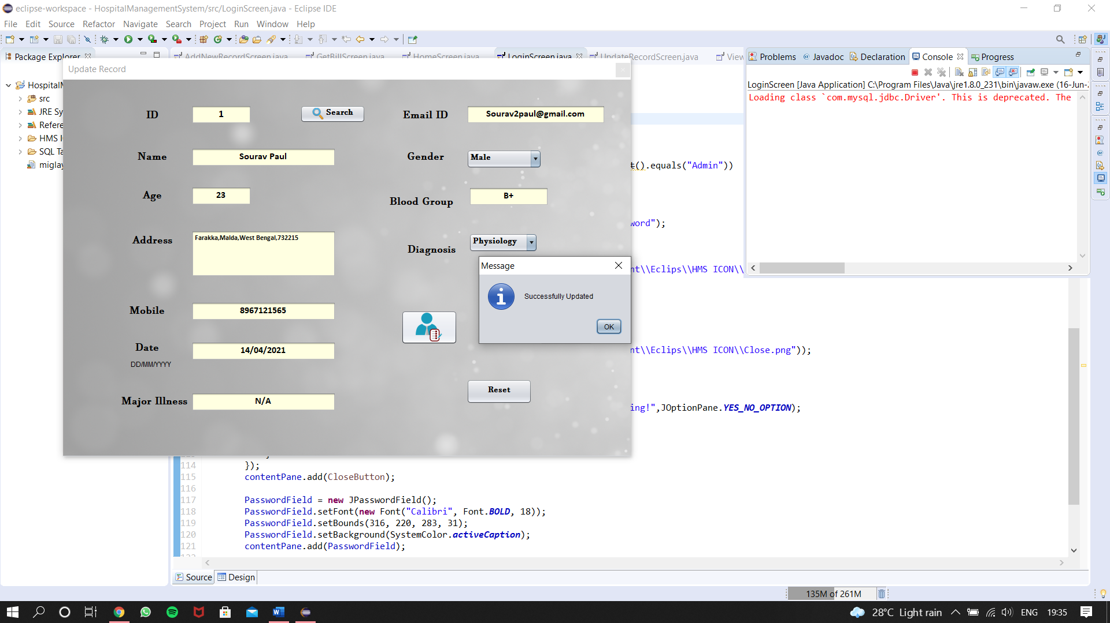

Fig-**4.d:** Successful Update Message

1. **View Record Window**: This window is to display all data or a particular record from data base.
   1. Initial Window (fig-5.a)

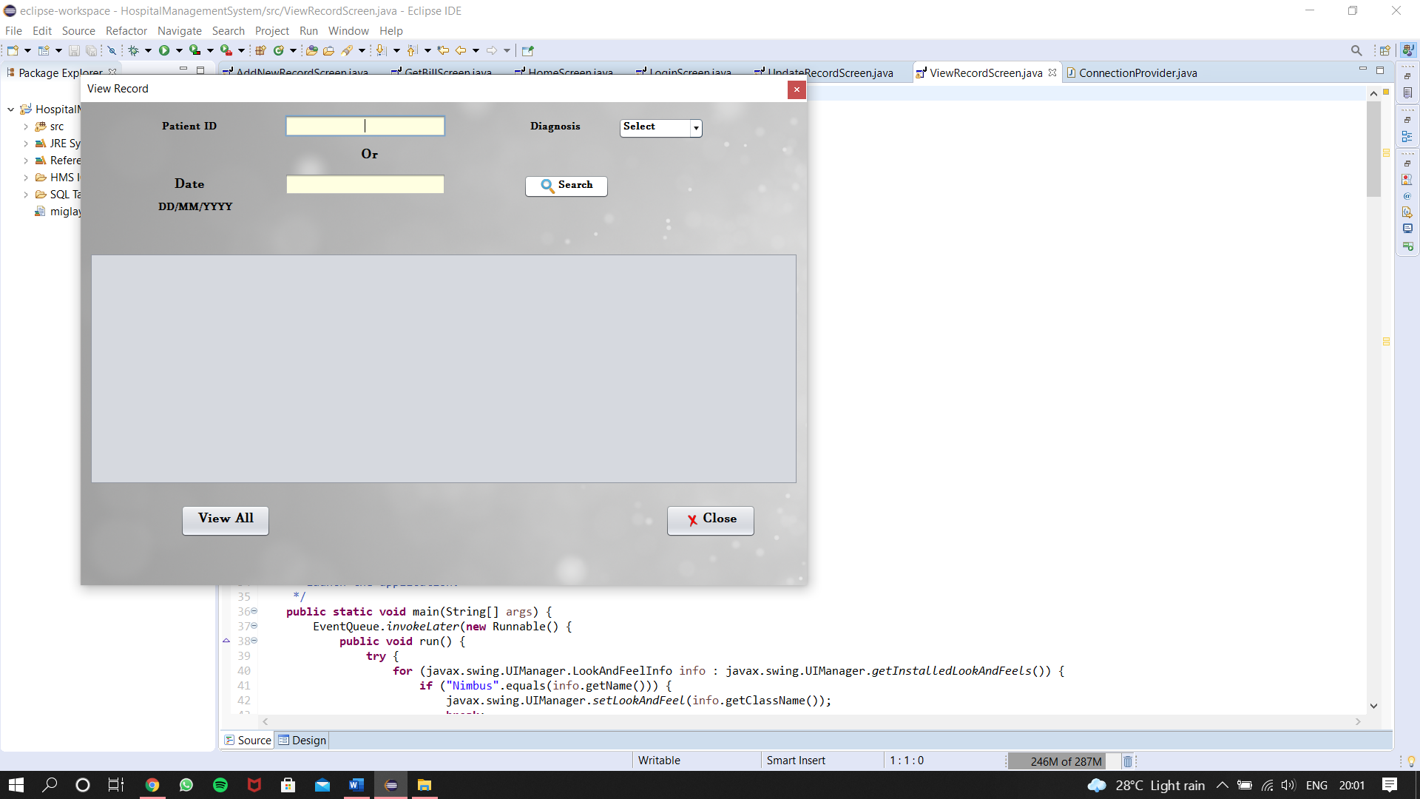

Fig-**5.a:** Initial View Record Screen

* 1. When there is no data in database (fig-5.b)

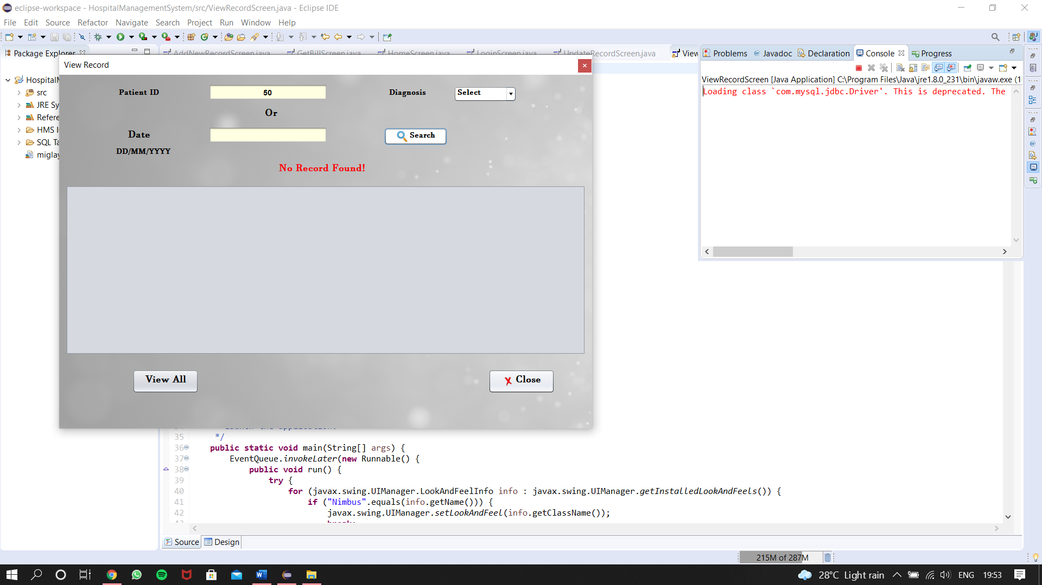

Fig-**5.b:** Invalid Details View Record Screen

* 1. When the database is not empty (fig-5.c)

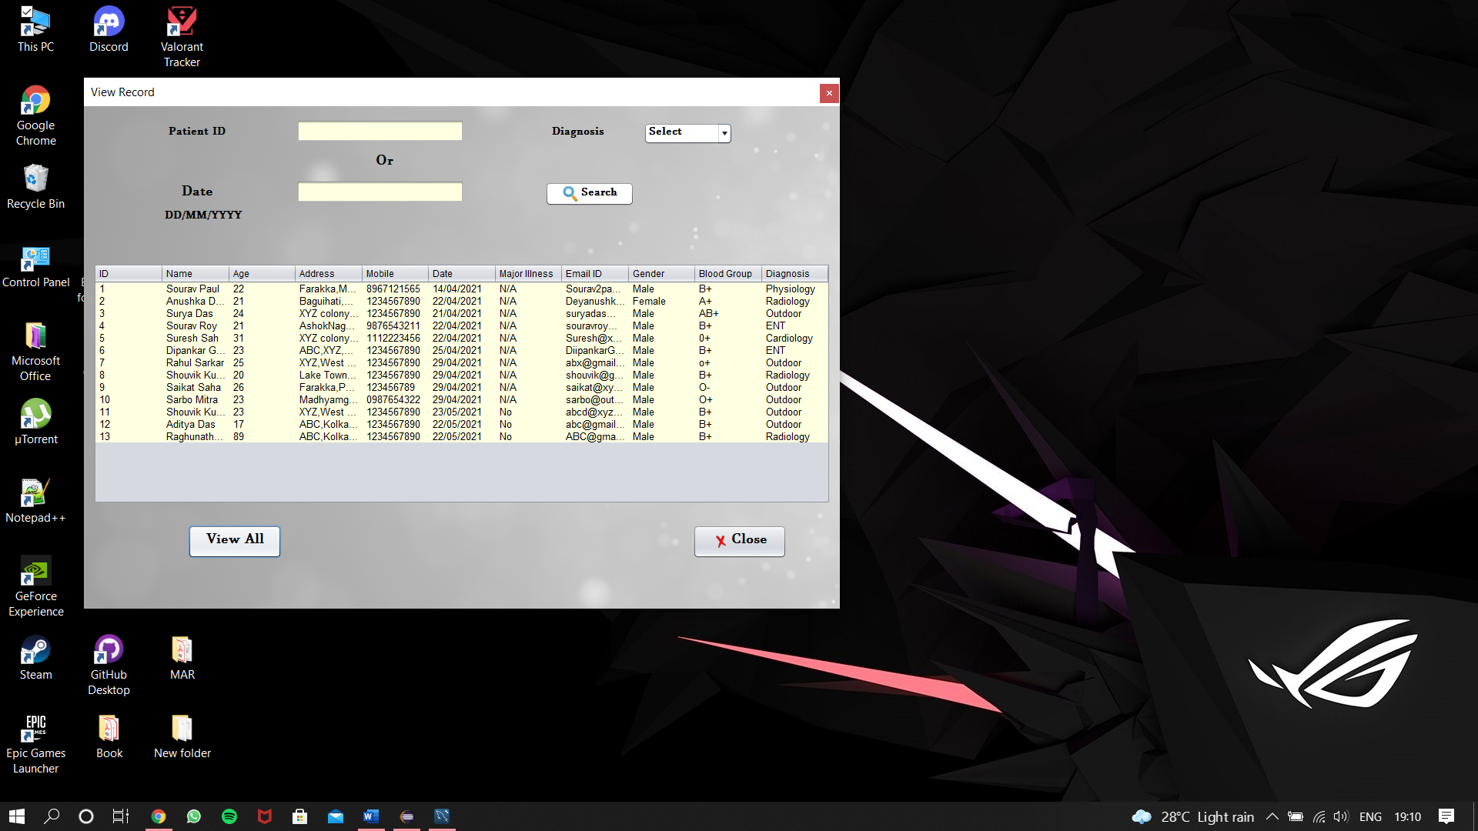 Fig-**5.c:** Valid Records

1. **Bill window**: This window is to generate bill.
   1. Initial window and window after reset (fig-6.a)

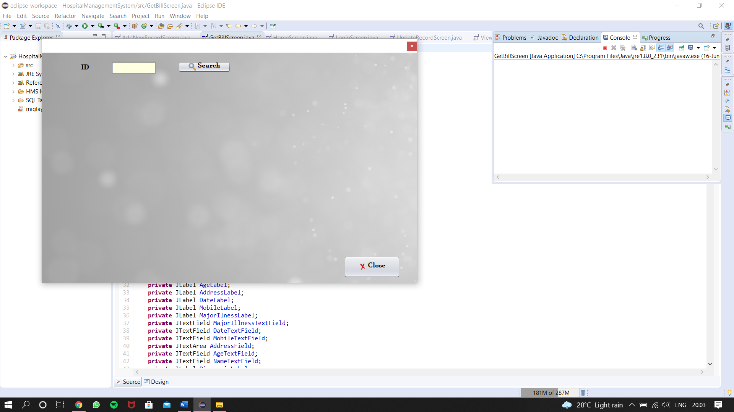

Fig-**6.a:** Initial Get Bill Screen

* 1. If ID does not exist (fig-6.b)

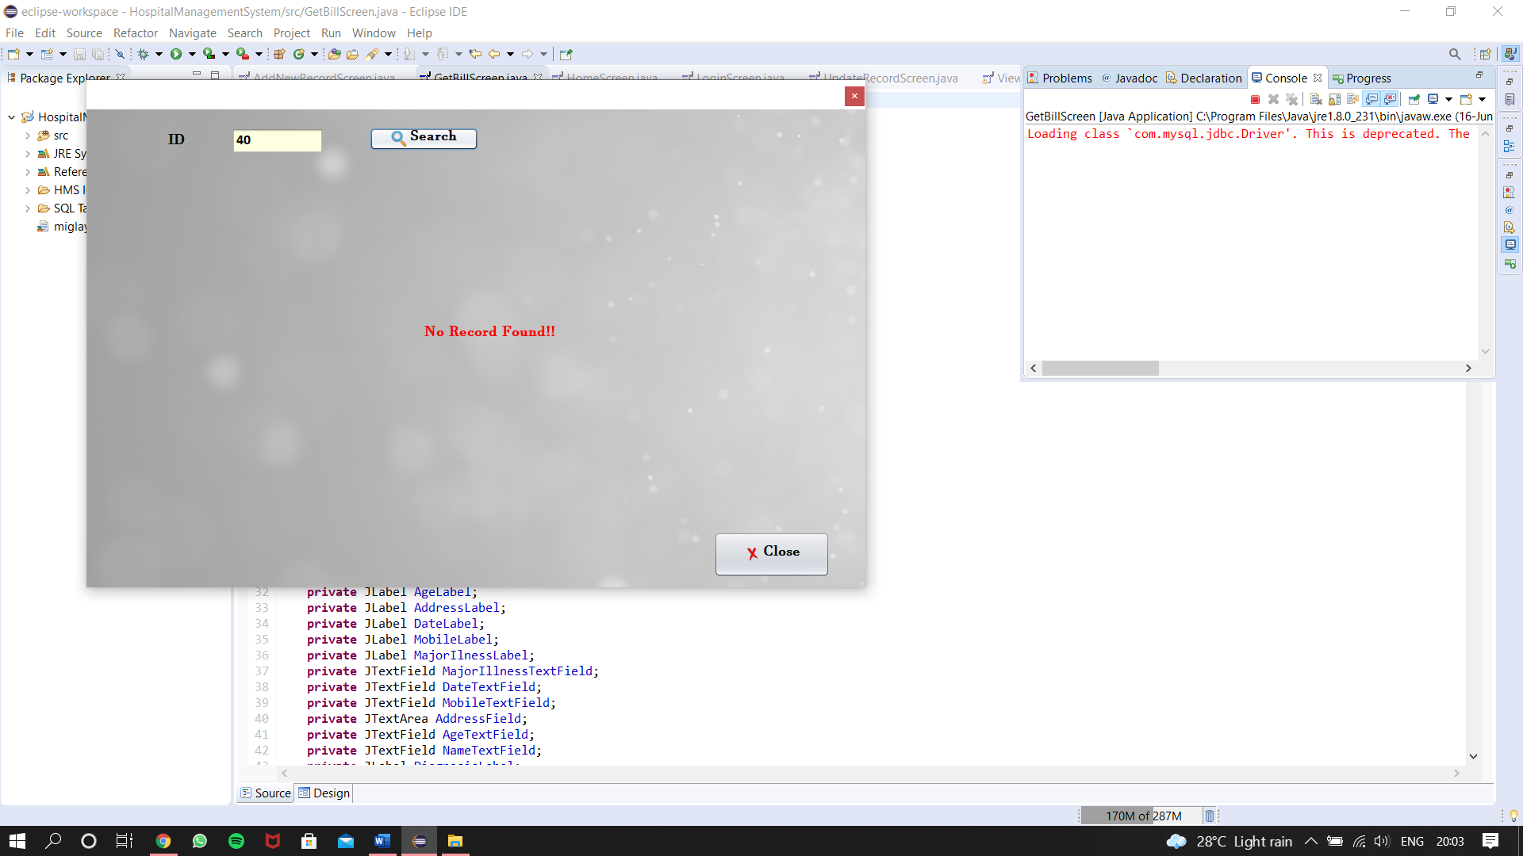

Fig-**6.b:** Invalid ID Get Bill Screen

* 1. If ID exist (fig-6.c)

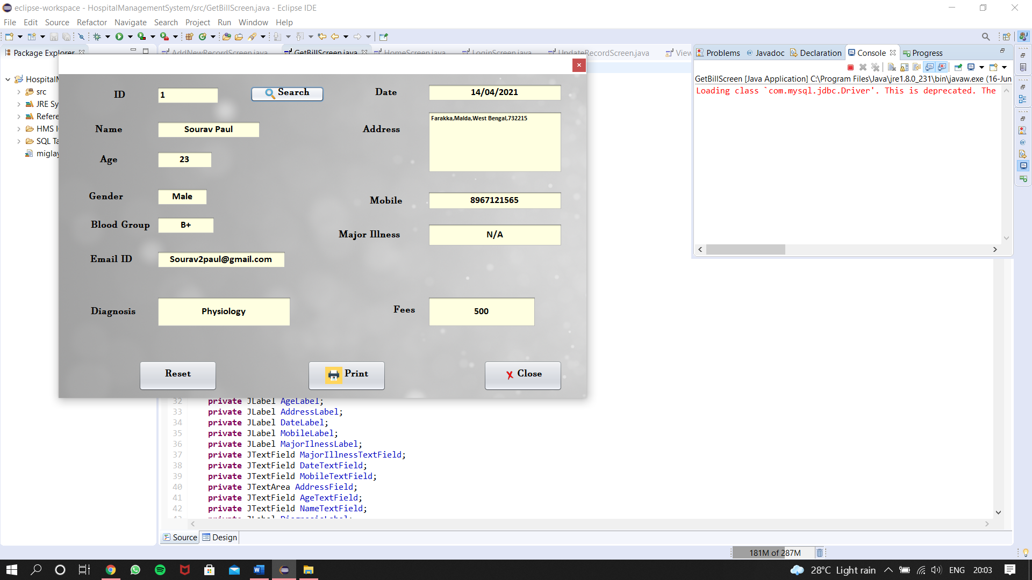

Fig-**6.c:** Valid ID Get Bill Screen

1. **Logout Screen**: This is just a button with a confirmation dialogue (fig-7.a).

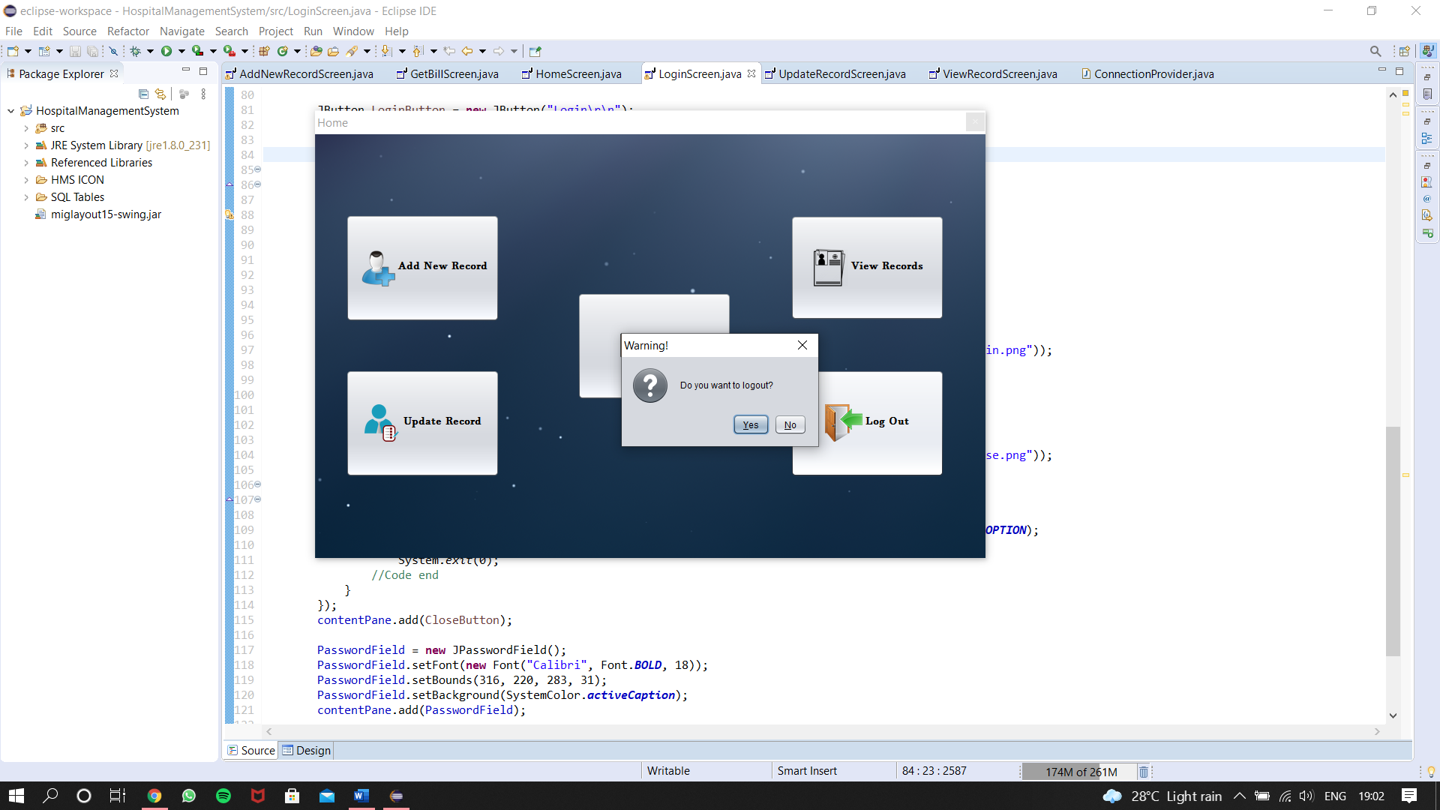

Fig-**7.a:** Logout Confirmation

CONCLUSION

* **Conclusions:**

The project Hospital Management System (HMS) are for computerizing the working in a hospital. The software takes care of all the requirements of an average hospital and are capable to provide easy and effective storage of information related to patients that come up to the hospital.

Overall, the project teaches us the essential skills like:

* We have gained an insight into the working of the HOSPITAL. This represents a typical real-world situation.
* Using system analysis and design techniques like data flow diagram in designing the system.
* Understanding the database handling and query processing.
* Scheduling a project and adhering to that schedule creates a strong sense of time management.
* Sense of teamwork has developed and confidence of handling real life project has increased to a great extent.

IMPORTANCE

# **Importance:**

1. As Hospital is a very needful and one of most necessary part of a civilization, and to organize the data of the hospital is very important.
2. As the modern age is the age of technology, and using pen paper for storing data can be time taking as well as hard to organize and even more difficult to access a particular data from that paper records.
3. Well organized, secured and easy to access application can do those paper works in a matter of time as well as can organize data so that finding a record will be easy.
4. But hospital is a vast organization and to organize every record from every timeline, for every department, the application should have more features which can be added with future work, like more department wise login credentials and features, more options for patients based on their diagnosis department.
5. A patient end portal or a pharmacy portal can be implemented for appointment booking or for prescription.

REFERENCES

* **References:**

1. Java: The Complete Reference by Herbert Schildt.
2. Abraham Silber Schatz, Henry F. Korth and S. Sudarshan “Sixth Edition Database System Concepts released
3. MySQL/PHP Database Applications, 2nd Edition by Brad Bulger
4. BinStock, Andrew (May 10,2015) “Java’s 20 years of Innovation”. Forbes. Archieved from the original on March 14,2016. Retrieved March 18, 2016
5. Ali Bahrami, “Object Oriented System Development, 3rd Edition Tata McGraw Hill Edition”.
6. Elmarsi and Navathe, “Fundamentals of Database System, Third Edition”, Addision Wesley.
7. Gosling, James; Joy, Bill; Steele, Guy; Bracha, Gilad; “The Java Language Specification, 2nd Edition”. Archieved from the original on August 5, 2011. Retrieved February 8, 2008.
8. Walter Shields, “Guide: The Simplified Beginner’s Guide to SQL”.
9. Brain Martin, “JDBC Developer Guide and References, 10g Release 2”.
10. Kathy sierra and Bert Bates, “Head First Java, 2nd Edition”.